Competition-Guangdong Pharmaceutical University School of Life Sciences and Biopharmaceutical Engineering

Project Proposal

Project Name: Microbial Loading of Biochar to Enhance Performance
Project Type: Entrepreneurship Training Program
Competition Category: Archbishop Track - Creative Group
Project Leader: Chen Fenglin
Other participating team members: Zhong Ruoyu, Wang Jingyao
Email address : flchen2023@163.com
Instructor: Wu Fenglin

Table of contents
Part One: Abstract
1.1 Product Introduction
1.2 Project logo
Part Two: Project Overview
2.1 Demand for Biochar
Figure 2.1.1 Overall Status and Major Problems of Soil Pollution in China
Table 2.1.2 Effects of biochar on soil CEC
Figure 2.1.3 Effects of nitrogen reduction combined with biochar application on aboveground dry matter accumulation in rice.
Table 2.1.4 Effects of nitrogen reduction combined with biochar application on the physical and chemical properties of paddy soil
Table 2.1.5 Removal and biodegradation of pollutants through biochar-microbe interaction
2.2 The Market for Biochar
2.3 Introduction to the methods used in the project
Table 2.3.1 Comparison of Immobilization Methods
2.4 Project Objectives and Content
Part Three: Product Introduction
3.1 Product Overview
3.2 Product Design
Part Four: Development Planning and Market Analysis
4.1 Market Prospect
Chart 4.1.1 Market Prospect
Chart 4.1.2 Trend of China's Biochar Market Size and Average Price , 2014-2023
Chart 4.1.3 Trends in China's Biochar Production and Sales
4.2 Market Characteristics
4.3 Competition Analysis
Chart 4.3.1 Competitive Advantage
4.4 Returns​
Figure 4.4.1 Value Creation and Realization Capability Assessment
4.5 Environmental Analysis
4.6 Comprehensive Analysis Table
Chart 4.6.1 Total Potential Analysis
4.7 Precautions
Part Five: Outlook
5.1 Business Model
5.2 Macroeconomic policy support
5.3 Specific offline implementation
Part VI: References

1. summary
1.1 Product Introduction
This project aims to develop a biochar product to reduce heavy metal pollution in soil, increase the levels of trace elements needed by crops in the soil, and improve grain yield.
biochar modified through different utilization methods , using the soil metal content and trace elements useful to crops obtained from the experiments as test indicators to compare the advantages of biochar with different utilization methods.
1.2 Project logo

the logo features a black whale, representing our product's powerful ability to fertilize and treat soil, much like a whale's ability to swallow prey. The lower part, in green, represents farmland, highlighting the benefits of our product for agricultural fields.
II. Project Overview
2.1 Demand for Biochar
The situation regarding heavy metal pollution and degradation in soil is currently very serious. Large tracts of arable land have had to be abandoned due to severe pollution, and residual heavy metals in the soil have rendered some land unusable. However, current methods for treating soil pollution mainly involve applying chemical amendments ; implementing biological remediation measures ; adjusting soil redox potential ; changing cropping systems ; and adopting agricultural ecological engineering measures.
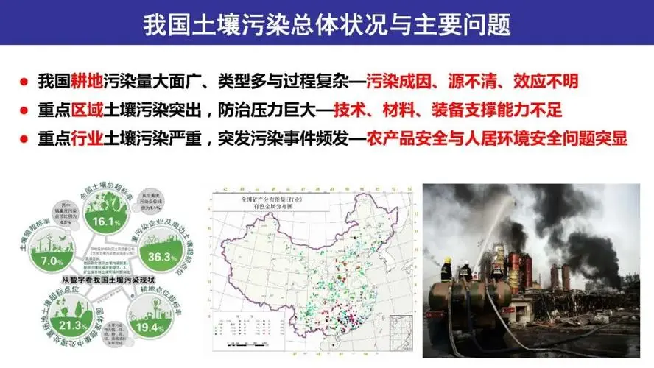
Figure 2.1.1 Overall Status and Major Problems of Soil Pollution in China
Biochar is a product with promising applications. It has a highly porous carbon-rich microporous structure that can absorb large amounts of greenhouse gases, adsorb heavy metals, and provide more space for microbial growth.
Biochar can be derived from agricultural waste such as wood, rice husks, and straw. It is also produced during the production of tar, with a current output of 50,000 tons, and is widely used in agriculture and wastewater treatment.
Biochar is often produced as a byproduct in the process of obtaining carbon compounds . Biochar has the functions of reducing soil metal pollution (e.g., the study of ELCP combined with biochar for solidification and remediation of heavy metal contaminated soil) and increasing the proliferation rate of soil microorganisms. If biochar can be better utilized, it can further reduce pollution caused by industrial development and extend the life of usable soil resources.
Soil CEC ( cation exchange capacity) Soil cation exchange capacity (CEC ) is one of the basic physicochemical properties of soil, indicating the soil's ability to retain exchangeable cations ( K ⁺ , Ca2 ⁺ , Mg2 ⁺ ) [21] . CEC has an important impact on the availability of nutrients and pollutants in soil, soil structure stability, soil fertility, and soil buffering capacity . According to existing research, biochar can significantly increase soil CEC when applied to various soils , which is of great significance for agriculture and environmental protection.

Biochar source​  Biochar source | Soil type  Soil type | CEC (mmol ^{C} • kg⁻¹ ) |  | References  References
 |  | No biochar added | Add biochar
Coffee shell | acidic soil | 24.90 | 34.90 | [4]
Coffee shell | Lateritic red soil | 19.10 | 40.40 | [4]
Coffee shell | Old soil | 2.30 | 23.10 | [4]
Wood waste | clay loam soil | 7.41 | 10.80 | [5]
dog tooth grass | silty soil | 1.00 | 1.54 | [6]
White-flowered horned melon | New soil | 29.00 | 49.00 | [7]
corn stalks | acidic red soil | 7.86 | 17.33 | [8]
Willow branches | acidic soil | 7.86 | 14.87 | [8]
wheat straw | Sandy loam | 2.09 | 2.47 | [9]
Table 2.1.2 Effects of biochar on soil CEC [3]
Table 1 The influence of biochar on soil CEC
research by N IELSEN [1] has demonstrated that biochar can increase the content of soil actinomycetes, and another study by L IM et al. [2] shows that the interaction between coexisting pollutants, biochar and microorganisms can affect the pollutant degradation rate of biochar-microorganism composites.
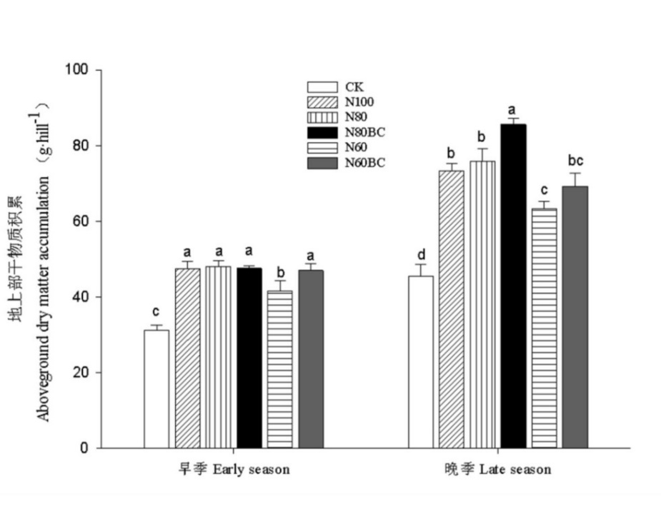
Figure 2.1.3 Effects of nitrogen reduction combined with biochar application on aboveground dry matter accumulation in rice [20]
Fig.1 Effects of nitrogen reduction combined with biochar application on aboveground dry matter accumulation of rice
In the above figure, ck represents the blank control treatment, and N groups represent groups using biochar with different nitrogen application levels. It is clearly visible that the rice yields of the groups using biochar all showed varying degrees of improvement. Biochar has a positive effect on the yield of both early and late-season rice , with a more significant effect on the yield of late-season rice.
deal with  Treatment | pH | electrical conductivity  Electrical  conductivity/  (μs· ^{cm⁻¹} ) | Total nitrogen  Total N/  (g ∙ kg ⁻¹ ) | Organic carbon  Organic C  (g· ^{kg⁻¹} ) | Carbon-to-nitrogen ratio  CN ratio | Total phosphorus  Total P/  (g· ^{kg⁻¹} ) | Total potassium  Total K/  (g· ^{kg⁻¹} )
CK | 5.6±0.0b | 42.9±8.2a | 1.37±0.01abc | 20.04±0.15b | 14.66±0.13bc | 0.58±0.05a | 12.16±1.06a
N100 | 5.5±0.1b | 47.4±4.3a | 1.25±0.02c | 20.44±0.70b | 16.30±0.28b | 0.54±0.08a | 11.49±1.37a
N80 | 5.7±0.0ab | 48.0±4.4a | 1.48±0.04ab | 20.16±0.35b | 13.63±0.29c | 0.56±0.09a | 11.74±1.14a
N80BC | 5.8±0.0a | 48.9±0.9a | 1.42±0.09abc | 30.19±1.75a | 21.27±1.05a | 0.65±0.04a | 10.73±1.30a
N60 | 5.6± 0.1b | 43.9±3.8a | 1.31±0.06bc | 20.14±0.57b | 15.46±0.64bc | 0.64±0.03a | 10.01±1.50a
N60BC | 5.8±0.1a | 47.1±3.4a | 1.55±0.08a | 32.65±0.23a | 21.25±1.30a | 0.60±0.02a | 11.76±1.41a
Table 2.1.4 Effects of nitrogen reduction combined with biochar application on the physical and chemical properties of paddy soil [20]
Table 2 Effects of nitrogen reduction combined with biochar on soil physical and chemical properties of rice
The table above shows that ck represents the blank control group, and N represents the groups using biochar with different nitrogen application levels . The information in the table shows that the use of biochar had both positive and negative effects on soil micronutrients. Exploring how to improve biochar to produce the desired positive effects on the soil is helpful in enhancing soil fertility.

Biochar raw materials  Biochar feed stock | microorganism  Microorganisms | pollutants  Contaminants | Initial concentration of pollutants  Initial concentrations of contaminants | Removal/Degradation  Removal/degradation (%) | pH | mechanism  Mechanism | References  References
straw | Bacillus sp. K1 | Cd(II) | 50 mg· ^{L⁻¹} | 95% | 7.0 | electrostatic attraction | [10]
pig manure | Geobacter​​​ | Cr(VI) | 115 mg· ^{kg⁻¹} | Rice roots absorbed Cr(VI) at a rate reduced by 46%–74%. | - | Oxybacterium induced iron dissimilatory reduction | [11]
cow dung | Acidophilus sp . , Sphingomonas​​​​ sp . , Blastococcus​ sp ) | tetracycline | 150 mg· ^{kg⁻¹} | 10% to 30% higher than that without biochar . | 6.5-9.0 | Alkaline pH inhibits the formation of tetracycline products. | [12]
casuarina seeds | Alcaligenes faecalis | Methylene blue | 50 mg· ^{L⁻¹} | 89.1% | 9.0 | Electrostatic attraction and reactive functional groups (=COC=, -NH) | [13]
Peanut shells | Pseudomonas citronellolis​​ | phenol | 400~1200 mg· ^{L⁻¹} | 46%~99% | 6.5~7.6 | π-π interactions adsorb phenol onto the micropores of biochar ; Pseudomonas citric acid secretes hydrolytic enzymes to degrade phenol. | [14]
Golden acacia (Acacia concinna ) | Bordetella petrii I GV 34 , Achromobacter xylophilus GV 47 xyloxidans GV  47) | Cypermethrin | 50 mg· ^{L⁻¹} | 98% | - | The hydrophobic interaction between biochar and cypermethrin subsequently produces biosurfactants for microbial degradation. | [15]
bamboo | Pseudomonas​ | Toluene | 2.2 g· ^{m⁻³} | 98.7% | 6.8 | Biochar promotes bacterial growth, resulting in higher adsorption and degradation efficiency . | [16]
corn stalks | Arthrobacter sp. | Atrazin | 50 mg· ^{L⁻¹} | 100% | 7.0 | Biochar provides bacteria with more binding sites and nutrients, thus improving the stability and intensity of bacterial degradation of atrazine. | [17]
Peanut shells | Pseudomonas citronellolis​​ | phenol | 600 mg· ^{L⁻¹} | 98.9% | 7.0 | SSA content , pore volume, and alkalinity of biochar promote bacterial growth, while adsorption and slow desorption reduce the toxicity of pollutants and promote phenol degradation. | [18]
straw | Shewanella oneidensis​​​ | Cr (VI) | 50 mg· ^{L⁻¹} | 34%~56.3% | 7.0 | The electrical conductivity and oxygen-containing functional groups of biochar promote synergistic effects with bacteria. | [19]
Table 2.1.5 Removal and biodegradation of pollutants via biochar-microbe interaction [9]
Table 2 Removal and biodegradation of contaminants through biochar-microbe interactions.

biochar made from different biochar raw materials can remove and biodegrade pollutants through biochar-microorganism interaction , which can significantly improve the treatment effect of bacteria on pollution. The porous structure of biochar can provide sufficient growth space for microorganisms and accelerate their proliferation rate.
In the current context of emphasizing environmental protection, biochar can make significant contributions to industrial wastewater treatment, soil conservation, and maintaining ecological balance. Furthermore, due to its porous structure, biochar effectively retains soil moisture. In China's vast arid northern regions, biochar can reduce the risk of crop mortality during droughts, facilitating the expansion of dryland farming areas, alleviating soil salinization caused by flood irrigation in the north, maintaining stable grain production, and reducing dependence on imported grain. The demand for biochar is far from saturated; therefore, improving biochar performance to expand its influence can better promote its market.

2.2 The Market for Biochar
Biochar is primarily used as a soil conditioner, accounting for 77.01% of total biochar consumption. In China, biochar is also mainly used for fertilizer production; in 2020, 24,731 tons of biochar were used for fertilizer. The biochar market has relatively low barriers to entry, is fragmented, and has many small, privately owned manufacturers. Many new companies specializing in biochar production also exist , selling their products through traders and online. As the biochar market is a niche industry, many large companies are startups, leading to a surge in new entrants in recent years. Competition is expected to intensify in the coming years, with increasing investment in biochar production and a growing market.

2.3 Introduction to the methods used in the project
with biochar include encapsulation, cross-linking, adsorption, and covalent bonding.
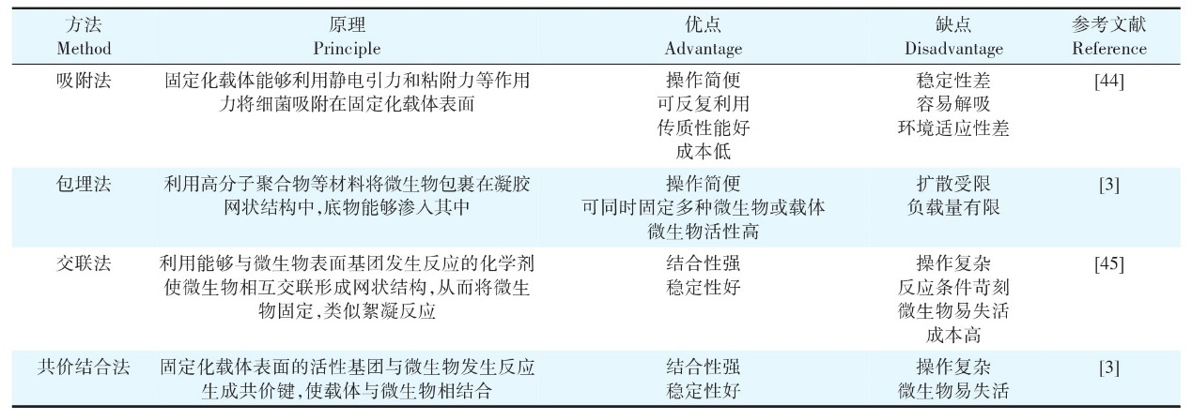Table 2.3.1 Comparison of immobilization methods [22]
Table 1 Advantages and disadvantages of immobilization carriers
Using changes in soil heavy metal ions and crop growth-required ions after microbial loading as indicators, the effects of different microbial loading methods on biochar performance can be determined.
Soil microorganisms are mainly divided into bacteria, fungi, actinomycetes, and algae. The changes in soil heavy metal concentration and crop-required ion concentration after biochar loading with these microorganisms can be used as indicators for evaluating biochar.

2.4 Project Objectives and Content
1. This project aims to improve the performance of biochar by loading it with microorganisms, including determining which microorganisms to use, what concentration of bacterial solution is most suitable as a loading material, and which method of immobilizing microorganisms will achieve the greatest benefit. The direction of biochar improvement will be to make it more suitable for agricultural and pollution control applications .
2. By immobilizing microorganisms on biochar using different loading methods, and using the changes in soil heavy metal concentration and crop ion concentration after biochar application as indicators, the biochar with the best pollution control and fertilization capacity is selected as the product.

- Product Introduction
3.1 Product Overview
carbon material made from biomass . It is an environmentally friendly and renewable resource that can be used as a soil conditioner, for treating wastewater and waste gas, for preparing electrode materials, catalysts, and adsorbents.
onto biochar to enhance its performance, producing high-efficiency biochar.

3.2 Product Design
biochar performance by loading microorganisms . It is currently speculated that encapsulating bacteria using the encapsulation method can maximize biochar performance , with Escherichia coli and nitrogen-fixing bacteria being the focus of the research.

IV . Development Planning and Market Analysis
4.1 Market Prospect
Currently, environmental protection is a key national priority, and biochar, a substance that is beneficial and harmless to the environment, has become a key target for promoting environmental protection. More efficient biochar can reduce pollution more quickly and effectively, protect soil resources, and maintain ecological balance, making it of great research value.
Table 4.1.1 Market Prospect
Market and profit margin related issues
standard | potential | Commentary
need | The biochar market has great potential. | The biochar market aligns with national environmental protection policies and provides agricultural insurance, making it a key area of government support.
client | The main customers are farmers, which represents a large customer base and has great potential. | my country is a major agricultural country with a vast amount of farmland and farmers. A significant portion of this farmland has been polluted due to industrial development, leading to a high demand for biochar and a huge market potential.
Rewards to users | > 2 years | Biochar's role is to control pollution and increase crop yields, but it takes a little longer to mature.
Increase or create value | High potential | Biochar can improve soil utilization and increase soil value. At the same time, the continuous promotion of biochar can expand the biochar market, creating a positive feedback loop.
Market size | Estimated to be over $400 million | Biochar not only benefits the domestic agricultural market but can also be transported overseas as an environmentally friendly material. With a huge domestic and international agricultural market, the market size of biochar will expand further if its development continues, and it is unlikely to encounter bottlenecks in the short term.
Market growth rate | > 15% | The biochar market is currently in its early stages of development, with significant room for growth.
Total Profit | Greater than 50% and sustained | biochar production are not expensive, with a cost of about 1,100 yuan per ton and a selling price of 1,800-2,100 yuan per ton. Although the profit margin is slowly decreasing, it is still very high .

Table 4.1.2 Trends in China's Biochar Market Size and Average Price , 2014-2023
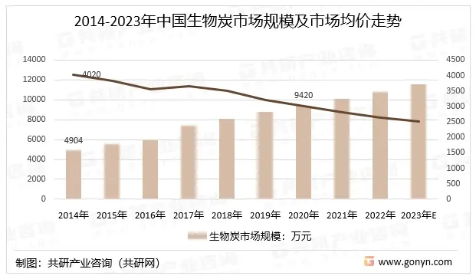
Table 4.1.3 Trends in China's Biochar Production and Sales
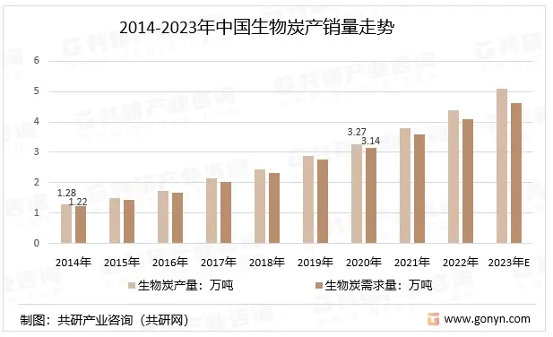
Image source: Gongyan Industry Consulting Network
The chart above clearly shows that biochar sales are constantly rising. However, given the large number of farmers and land in China that needs remediation, the biochar market is far from saturated and has huge potential.

4.2 Market Characteristics
Biochar primarily targets the environmental protection and agricultural markets, both of which are key areas of national investment and support. However, due to the relatively short research history of biochar, market regulation is inadequate, and product costs are high, resulting in a small current market share with untapped potential.
4.3 Competition Analysis
Biochar is a byproduct of the production of other carbon compounds. It has a wide range of sources and can lock in unstable carbon elements in the soil that cause climate change, improve soil structure, increase soil porosity, increase soil water holding capacity, and reduce soil heavy metal and organic pollution, among many other environmental benefits. Therefore, biochar has much better performance than similar pollution control substances. However, at present, the main source of biochar production is agriculture, and the large-scale collection system is not perfect, which weakens its market competitiveness.
Table 4.3.1 Competitive Advantages
standard | potential | Commentary
Fixed and variable costs | Low | Biochar production costs are not high, but the costs of raw materials and equipment are already very low, its compressibility is poor, and its costs are relatively fixed.
Price and cost | lower | The price and cost elasticity are low, prices remain largely unchanged, and profits are relatively stable.
Supply and distribution channels | powerful | Currently, the main sources of raw materials for biochar are leftover straw and sugarcane bagasse from farmers' production, which are relatively scattered. It is highly feasible for companies to collect raw materials from farmers, as the raw materials are not monopolized. Moreover, farmers are a major customer of biochar, allowing companies to promote biochar while sourcing it, thus enhancing its market influence. Furthermore, biochar is a byproduct of tar production, with a significant output, low price, and ample supply.
Entry barrier | Small obstacles | biochar market is far from saturated, and barriers to entry are low.
Advantages | powerful | Compared to other fertilizers and pollution control products, biochar is characterized by its low price and high efficiency, and it is fully capable of taking over the market share of other products.
First-mover advantage | powerful | Biochar production relies primarily on machinery, with minimal dependence on manual labor. Furthermore, biochar is a byproduct of tar production, and the technology for processing it is well-established. The raw materials for biochar are widely distributed, so there is no concern about raw material shortages.
Advantages of Service Chain Contracts | Strong | Biochar production can connect farmers and tar companies by using tar production and agricultural production as upstream raw material sources and farmers purchasing the raw materials downstream.
opportunity | good | The biochar market is still in its early stages of development, making it an opportune time for companies to enter the market.
4.4 Returns
Table 4.4.1 Value Creation and Realization Capability Assessment
standard | potential | Commentary
After-tax profit | 3.5 % and relatively stable . | Biochar is a product that aligns with national policies and enjoys government support; therefore, it's worth considering applying for tax reductions.
Recovering time costs | Six months to a year | The net profit per ton of biochar is between 700 and 1000 yuan. The cost of equipment can be recovered within a year of production. Moreover, biochar is convenient to store and transport, and has low cost.
to achieve positive cash flow | One to two years | The longer you work on it, the more biochar sources you can collect, thus expanding the biochar industry chain and increasing revenue.
value | High strategic value | Biochar has a broad market and high demand. It can also alleviate some soil problems, align with national policies, and has high strategic value.
Capitalization requirements | Low, investable | current weakness of the biochar market is the fragmentation of raw materials and consumption locations. If a company could consolidate the market, it would significantly increase the brand awareness of biochar, making it a very suitable investment product.
Investment risks | Low | Biochar is more efficient than other products, has no expiration date, is easy to store, has high demand, and carries very low investment risk.
Total value creation potential | Timing: Good  Profit/Net Cash Flow: High  Exit/Liquidity: Good | The biochar market is currently untapped, making this an excellent time to invest. Biochar has low costs, high profits, is more efficient than other products, has no expiration date, carries minimal risk, and allows companies to exit the market at any time.

4.5 Environmental Analysis
Since the awakening of environmental awareness, China has been vigorously promoting the development of environmental protection, providing enormous opportunities for the promotion of biochar. Furthermore, due to the declining proportion of arable land in the total utilized land and the famine caused by uneven food distribution under the pandemic, increasing crop yields is one of the important ways to solve the food problem. Biochar can effectively contribute to increasing food production and promote agricultural development. Therefore, the environment for biochar is excellent, making research into more efficient biochar methods essential.

4.6 Comprehensive Analysis
Table 4.6.1 Total Potential Analysis
standard | Feasibility | Commentary
Profit margin and market | feasible | Biochar is highly profitable, but market development is still in its early stages.
competitive advantage | feasible | Biochar is more efficient than similar wastewater treatment and fertilizer products, giving it a strong competitive advantage.
Value creation and realization | More feasible | Biochar has extremely high value and can generate substantial profits, but its effectiveness needs time to be verified after use .
Compatibility: Business Opportunities + Resources + Team | feasible | With high profit margins, alignment with government policies, and a wide range of raw material sources, the company is open to investment to expand the influence of biochar and tap into the biochar market .
Risk-reward ratio | feasible | Biochar has low storage costs, no shelf life, and low investment risk .
opportunity | feasible | The biochar market is still in its early stages and has great potential for growth.

4.7 . Precautions:
One of the current problems in the development of biochar is the lack of integration of raw material sources and the relatively scattered production areas. Enterprises need to gradually integrate the raw materials from farmers and unify the entire biochar market. This is a huge undertaking and requires enterprises to continuously accumulate capital.
The main sales areas for biochar are also scattered due to the dispersed nature of farmers. Therefore, if companies want to increase biochar sales, they need to spend a lot of manpower to actively contact farmers or village committees with hundreds of farmers to sell the biochar on their behalf and ensure the sales volume of biochar.
What biochar urgently needs is an influential brand, to gradually enter the market and establish a stable market share. This takes time. Therefore, a portion of the sales profits from biochar needs to be invested in market development, which is a long-term process. Once biochar becomes well-known among farmers, it will be no problem to occupy the market due to its high efficiency. The important thing is that the initial investment requires manpower and resources.

V. Future Prospects
5.1 Business Model
of biochar are tar refining enterprises and agricultural waste left over from farming. To standardize biochar production, it is necessary to obtain these resources from tar refining enterprises and agricultural waste.
We need to establish a company that can actively communicate with businesses and farmers, connecting upstream raw material acquisition with downstream product sales. This company would integrate the biochar sources from farmers and private enterprises , process them uniformly, and then sell them.
Currently, farmers are the main consumers of biochar . In the future, we could consider developing the market by also targeting pollution control companies.
Stabilizing biochar production and establishing a firm foothold in agriculture before gradually expanding its influence is a development model that can better expand the biochar market .

5.2 Macroeconomic Policy Support
The desire for "green mountains and clear waters" has been advocated for several years, and the country has been promoting environmental protection policies. The promotion of biochar is in line with national policies.
.
5.3 Specifically, this can be implemented offline.
Since biochar is a relatively new pollution control product, the market is quite chaotic and the source of biochar is unstable. It would be helpful to find a leading organization to take the lead in integrating the market, unifying the management of upstream and downstream, maintaining the order of the biochar market, and providing better support for biochar research and promotion.

VI. References
- REN TB, GAO WK, XU CS, et al. Comparative analysis of the microbial communities in agricultural soil amended with enhanced biochars or traditional fertilisers [J]. Agriculture, Ecosystems and Environment, 2014, 191: 73-82.
- LI M, YIN H, ZHU M, et al. Co-metabolic and biochar-promoted biodegradation of mixed PAHs by highly efficient microbial consortium QY1[J]. < i >Journal of Environmental Sciences</ i >, 2021, 107: 65-76.
- Zhao Shuwen, Zhang Qianru, Zhang Chuchen, Ji Linyu, OK Yongsik . Research progress on biochar-microbe interaction in soil pollution remediation [J]. Journal of Agricultural Environmental Science: 1-17.
- DOMINGUES R R , SANCHEZ-MONEDERO MA, SPOKAS KA, et al. Enhancing cation exchange capacity of weathered soils using biochar: Feedstock, pyrolysis conditions and addition rate[J]. < i >Agronomy</ i >, 2020, 10(6): 824.
- GHORBANI M, ASADI H, ABRISHAMKESH S. Effects of rice husk biochar on selected soil properties and nitrate leaching in loamy sand and clay soil[J]. < i >International Soil and Water Conservation Research</ i >, 2019, 7(3): 258-265.
- HUFF MD, KUMAR S, LEE J W. Comparative analysis of pinewood, peanut shell, and bamboo biomass derived biochars produced via hydrothermal conversion and pyrolysis[J]. < i >Journal of Environmental Management</ i >, 2014, 146: 303-308.
- AMIN A. Carbon sequestration, kinetics of ammonia volatilization and nutrient availability in alkaline sandy soil as a function on applying calotropis biochar produced at different pyrolysis temperatures[J]. < i >Science of the Total Environment</ i >, 2020, 726: 138489
- CHINTALA R, MOLLINEDO J, SCHUMACHER TE, et al. Effect of biochar on chemical properties of acidic soil[J]. < i >Archives of Agronomy and Soil Science</ i >< i >,</ i >2014, 60(3): 393-404.
- LIU Y, ZHU J, GAO W, et al. Effects of biochar amendment on bacterial and fungal communities in the reclaimed soil from a mining subsidence area[J]. < i >Environmental Science and Pollution Research</ i >, 2019, 26: 34368-34376.
- WANG L, LI Z, WANG Y, et al. Performance and mechanisms for remediation of Cd (II) and As (III) co-contamination by magnetic biochar-microbe biochemical composite: Competition and synergy effects[J]. < i >Science of the Total Environment</ i >, 2021, 750: 141672.
- XU​​​​
- YUE Y, LIU YJ, WANG J, et al. Enrichment of potential degrading bacteria accelerates removal of tetracyclines and their epimers from cow manure biochar amended soil[J]. < i >Chemosphere</ i >, 2021, 278: 130358.
- BHARTI V, VIKRANT K, GOSWAMI M, et al. Biodegradation of methylene blue dye in a batch and continuous mode using biochar as packing media[J]. < i >Environmental Research</ i >, 2019, 171: 356-364.
- ZJANG G , GUO​​​​​​
- ODUKKATHIL G, VASUDEVAN N. Bacteria amended clay biochar composite biobed system to treat agriculture runoff[J]. < i >Journal of Environmental Management</ i >, 2020, 269: 110694.
- LIN CW, TSAI SL, LAI CY, et al. Biodegradation kinetics and microbial dynamics of toluene removal in a two-stage cell-biochar-filled biotrickling filter[J]. < i >Journal of C</ i >< i >leaner Production</ i >, 2019, 238: 117940.
- YU T, WANG L, MA F, et al. A bio-functions integration microcosm: Self-immobilized biochar-pellets combined with two strains of bacteria to remove atrazine in water and mechanisms[J]. < i >Journal of Hazardous Materials</ i >, 2020, 384: 121326.
- ZHAO L, XIAO D, LIU Y, et al. Biochar as simultaneous shelter, adsorbent, pH buffer, and substrate of < i >Pseudomonas </ i >< i > citronellolis </ i > to promote biodegradation of high concentrations of phenol in wastewater[J]. < i >Water Research</ i >, 2020, 172: 115494.
- RI C, TANG J, LIU F, et al. Enhanced microbial reduction of aqueous hexavalent chromium by < i >Shewanella</ i >< i > oneidensis </ i > MR-1 with biochar as electron shuttle[J]. < i >Journal of Environmental Sciences</ i >, 2022, 113: 12-25.
- Chen Hailang, Luo Jiaxin, He Yang, Ning Chuanchuan, Liu Rui, Tian Jihui, Cai Kunzheng . Effects of nitrogen reduction combined with biochar application on rice productivity and soil bacterial community composition [J]. Journal of Agricultural Environmental Science: 1-18.
- RAZZAGHI F, ARTHUR E, MOOSAVI A A . Evaluating models to estimate cation exchange capacity of calcareous soils[J]. < i > Geoderma </ i >, 2021, 400: 115221.
- Du Zhaolin , Chen Hongan, Yao Yanpo, An Yi. Research progress on biochar immobilized microbial remediation of contaminated soil [J]. Journal of Agricultural Environmental Science, 2022, 41(12):2584-2592.

